**Storage in AWS**

* Storage Needs for a typical organization
  + Backups, archives, log files etc
  + Hard drives, network file shares (SAN, NAS) etc
  + Any files so that they can be downloaded (BLOB)
* In AWS, we deal with virtual storage, so we need services for
  + Hard drives => Block Storages => Elastic Block Storage (EBS):
    - File Systems based on os (i.e. NTFS for windows, ext4/xfs/zfs on linux ) will be created on this disk (volume)
    - The Backup of this volume is called as snapshot.
    - EBS Volumes have types based on hardware
      * Hard disk drive (HDD)
      * Solid State Drive (SSD)
      * Magnetic disk
    - EBS Volumes speed is measured in IOPS (1 IOPS => 256KB/s (ssd)) and throughput (units/second)
    - EBS Volumes are scoped to Availability zones.
  + Network file share
  + BLOBs

**Disk Storage**

* EBS is a block storage which is allocated from a different physical server than ec2 instance
* Instance store is the block storage which is allocated from the same physical server where ec2 instance is created.
* EBS can exist even after ec2 instance is deleted where as instance storage cannot exist.
* Instance store is not supported for all the ec2 instance types, they exist for special needs only.  
  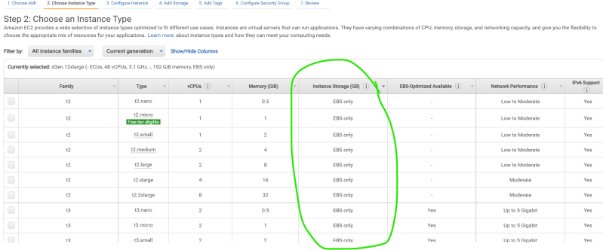  
  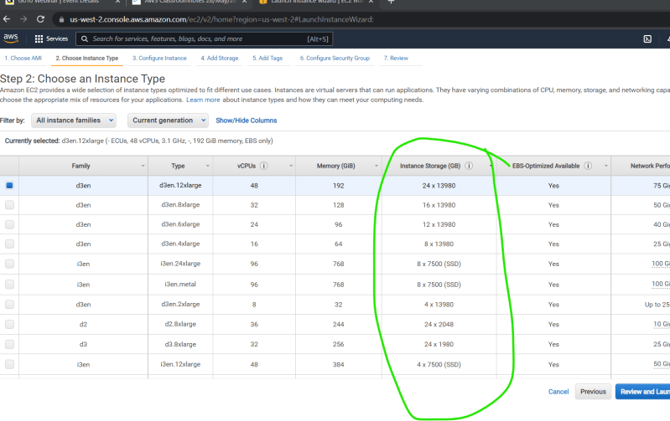

**Network Storage**

* EFS & FSx are the services which provider network file shares alternatives to SAN/NAS storages
* EFS & FSX support sync between AZ’s